Development of a Simple R Package (aLBI) for the Estimation of Stock Status from the Length Frequency Data

Ataher Aliª, Mitu Ranjan Sarker^{b}, Mohammed Shahidul Alamª*

ªDepartment of Fisheries, University of Chittagong, Chattogram- 4331, Bangladesh; ataher.cu.ms@gmail.com; alamms@cu.ac.bd
^{b}Institute of Marine Sciences, University of Chittagong, Chattogram- 4331, Bangladesh; mitusarkerims@cu.ac.bd

*Correspondence author e-mail: alamms@cu.ac.bd

ABSTRACT
Stock assessment is a difficult task for sustainable fisheries management especially when population and fisheries data are limited. This study aims to develop a simple and well-tested R package (aLBI) to facilitate the fish stock status assessment by providing robust functions for estimating length-based indicators (LBIs) and the stock heath by utilizing the length frequency data. The primary objective is to streamline the calculation of different size classes and visualization of the estimated metrices for more accurate and efficient understanding. The package includes two main functions for calculating key LBIs such as maximum length (L_{max}), asymptotic length (L∞), length at sexual maturity (L_{mat}), optimum length (L_{opt}), L_{opt}±10% (L_{opt_p10}, L_{opt_m10}) and percentages of fish at maturity (P_{mat}), optimum length (P_{opt}), and mega spawners (P_{mega}) with confidence intervals by bootstrapping method. This study also evaluated the performance of accuracy of this package by validating with real world length frequency data of Sperata aor with different bin size. The findings with a calculated optimum bin size three demonstrate its utility in producing reliable stock assessments, with mean estimates for L_{max}, L∞, L_{mat}, and L_{opt} at 74.27 cm, 78.17 cm, 41.83 cm, and 44.77 cm, respectively, as well as respective confidence intervals. Besides, percentages of fish at maturity, optimum length, and mega spawners are 12.48%, 9.03%, and 5.09%, against targets of 100%, 100%, and 20% respectively. Additionally, the stock status indicators show probabilities of 67% for both TSB40 and LSB25 for base model. By integrating advanced statistical methods and user-friendly interfaces, aLBI enables effective monitoring of fish populations and informed decision-making. Tested on various bin size (1, 2, 4 and 5) with a dataset, the package consistently performs accurately. Its ease of use and robust inferences make it an essential resource for researchers and managers. Future recommendations include expanding functionality to cover more species and integrating additional biological parameters for enhanced stock assessments. Continued collaboration with the fisheries science community will ensure aLBI remains a cutting-edge tool for sustainable fisheries practices.

Key words: R package development, stock assessment, aLBI, length-based indicators (LBIs), target biomass, limit biomass, Kaptai Lake.

INTRODUCTION
Fish stock assessment is a crucial element in the management and conservation of fishery resources, aiming to provide reliable estimates of fish population dynamics, exploitation levels, and sustainable yield. Effective fish stock assessment ensures that fishery management decisions are based on sound scientific evidence, promoting the long-term sustainability of marine ecosystems and the fishing industry (Hilborn & Walters, 1992; FAO, 2020). It allows for the determination of fishing quotas, the identification of overfished stocks, and the implementation of conservation measures. Without reliable stock assessments, fisheries management cannot effectively balance exploitation with conservation, leading to the depletion of fish stocks and the collapse of fisheries (Pilling et al., 2008; Punt et al., 2016; Punt et al., 2020). Thus, knowledge about the population status is critical for effective management (Alam et al., 2021). However, the application of traditional stock assessment methods to these populations is often hampered by numerous changes, such as challenges in data collection due to the lack of monitoring and control programs (Hilborn and Walters, 1992; Scott et al., 2016). Given this situation, several stock assessment methods have been developed for data-limited fisheries. Among these methods, some require yearly landing data and life history parameters (i.e., natural mortality, maximum age, age at maturity) (Martell and Froese, 2013; Thorson and Cope, 2015; Prince et al., 2015; Zhou et al., 2017; Free et al., 2017; Canales et al., 2018), while other require length-frequency data in cohort analysis models (e.g., Hordyk et al., 2014; Nelson, 2017; Froese et al., 2018; Prince et al., 2015; Rudd and Thorson, 2018; Ault et al., 2019). Collecting length-frequency data is often more straightforward and cost-effective than gathering of landing landings data, and the resultant data tend to be more reliable (Chong et al., 2020; Pilling et al., 2008; Hordyk et al., 2015; Mildenberger et al., 2017; Froese et al., 2018).
Thus, length-based stock evaluation methods provide a good and typically more practical option (Pauly & Morgan, 1987). Using length frequency data, these techniques estimate significant population parameters like patterns of recruitment, growth rates, mortality rates due from natural causes and fishing, and so on (Sparre & Venema, 1998; Gelman & Shalizi 2013). One consistent approach to find length frequency information is to look at fish landings or market samples. Due to their economic viability and readily accessibility application of length frequency data based stock assessment models become increasingly popular, particularly in areas with low financial and technological resources (Gayanilo & Sparre et al., 2005; Hoggarth et al., 2006).
The Sperata aor (Hamilton, 1822), commonly known as the long-whiskered catfish, is an important species within the Bagridae family, widely distributed across freshwater systems in South Asia, including the river basins of the Ganges, Brahmaputra, and Indus. In Bangladesh, this species is notably prevalent in Kaptai Lake, an artificial reservoir created by damming the Karnaphuli River in the Chittagong Hill Tracts in 1966. Kaptai Lake is vital for supporting local fisheries, including S. aor, which plays a crucial role in the livelihoods of numerous fishing communities in the region (Hossain et al., 2012). The lake is a significant source of fish for local markets, contributing to both food security and the local economy (Shalehin et al., 2022). However, increased fishing pressure, along with environmental changes and habitat degradation, has raised concerns about the sustainability of many fish stocks including S. aor populations in Kaptai Lake (Khatun et al., 2023). This situation highlights the need for effective management and conservation strategies to ensure the long-term viability of this vital fishery. Given the cultural and economic significance of S. aor in local diets and traditional practices, sustainable exploitation and conservation efforts are crucial for maintaining ecological balance in Kaptai Lake and preserving the biodiversity that supports local communities (Rana et al., 2024).
Numerous metrices based on length data have been developed to evaluate the status of fish stocks (Mildenberger et al., 2017; Hordyk et al., 2015; Froese et al., 2018; Froese, 2004). Among these, three length-based indicators (P_{mat}, P_{opt}, P_{mega}) proposed by Froese (2004) have gained prominence due to their simplicity and utility. These indicators assess exploited fish stocks using straightforward, data-limited approaches based on length-frequency distributions. They are particularly advantageous for fisheries where detailed stock assessments are impractical, as they focus on the distribution of fish lengths relative to key biological reference points (Froese, 2004; Cope & Punt, 2009). By simplifying the evaluation of stock sustainability, these metrics serve as practical tools for both scientific research and fisheries management in data-limited settings. Given that the simplicity and length data requirement, this study aimed to evaluate the stock status of S. aor in the Kaptai Lake. Furthermore, this study also

primarily aims to create a scientifically valid, user-friendly, robust R software for length-based fish stock assessment. Thus, this study intends to design and develop an R package that integrates advanced statistical models and visualization tools for fisheries data analysis. In addition, it aims to provide comprehensive documentation and user support for the package and validate the R package by using real-world length frequency data of S. aor.

METHODOLOGY

Study area
This study focuses on the collection of length frequency data of S. aor from Kaptai Lake, located in the Chattogram district of Bangladesh. The lake lies in the southeast part of Bangladesh, within the coordinates of latitude 22°22' to 23°18'N and longitude 92°00' to 92°26'E (Figure 1).
Kaptai Lake, the largest man-made freshwater lake in the country with a water area of 68,800 hectares which is 1.46% of the total inland open water bodies (DoF, 2023), is a vital resource for local fisheries and communities. The lake interconnects several upazilas, including Rangamati Sadar, Langadu, Nannerchar, Jurachari, Kaptai, and Belaichari. It is fed by the Karnaphuli, Chengi, Mayani, Kassalong, and Rinkhyong rivers. Fishing activities in Kaptai Lake play a crucial role in the livelihoods of local communities and contribute significantly to Bangladesh's inland fisheries production (Galib et al., 2018; Suman et al., 2021; Shalehin et al., 2022). As the largest artificial lake in the country, Kaptai Lake provides an expansive fishing ground, supporting both commercial and subsistence fishing practices (Rahman et al., 2024). The lake is home to a wide variety of freshwater fish species, including native species like catfish (Sperata aor, Mystus spp.) and carps (Labeo rohita, Cirrhinus mrigala), as well as introduced species like tilapia (Oreochromis spp.) (Lima et al., 2023).
Kaptai lake fisheries multi-species and multi-gear in nature (Rahman et al., 2024) where fishing methods employed in range from traditional techniques such as cast nets, gill nets, traps, and seine nets to modern fishing gear for commercial operations. Seasonal fishing activities, heavily influenced by monsoon patterns, are vital for meeting the local demand for protein and generating income. However, overfishing, habitat degradation, and water level fluctuations pose challenges to the sustainability of these activities. Efforts to manage Kaptai Lake’s fisheries include community-based management and government interventions to ensure stock sustainability. Notably, seasonal fishing bans (April to July) and the establishment of conservation zones are key strategies implemented to maintain fish biodiversity and regulate fishing activities. These approaches aim to balance ecological preservation with the socio-economic needs of local communities. Studies have highlighted the significance of closed fishing periods in aiding fish reproduction and replenishing stocks, while conservation zones serve as critical habitats for spawning and juvenile development (Pearce et al., 2002; Suman et al., 2021; Shalehin et al., 2022)

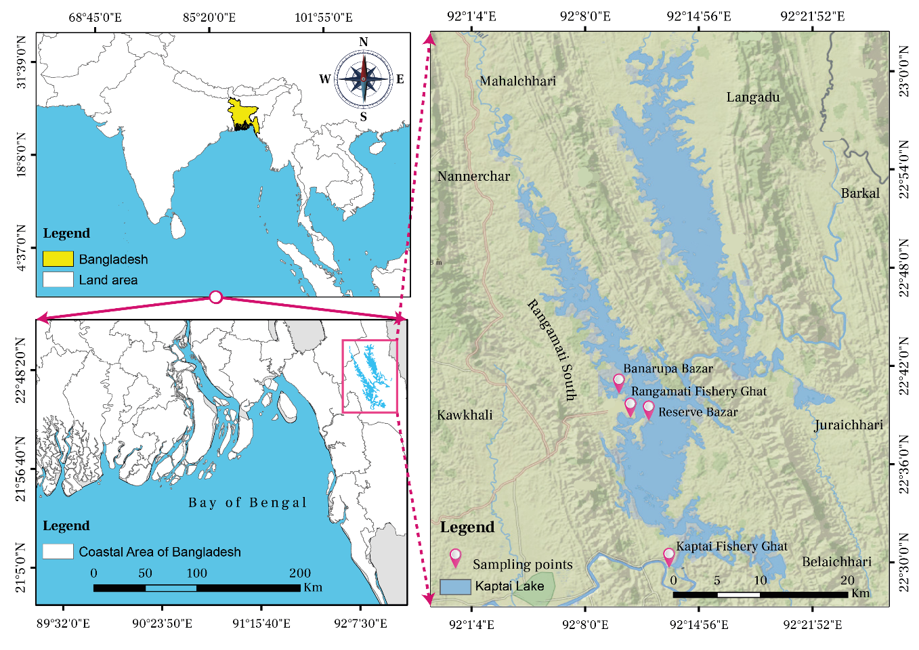
Figure 1: Map showing the sampling points of the study

Collection of length frequency data
Length-frequency data were collected from four sampling stations (Figure 1): the Rangamati (22°38'55.22"N & 92°11'4.41"E) and Kaptai (22°29'51.12"N & 92°13'11.66"E) landing centers, along with two local markets, Banarupa Bazar (22°39'13.36"N & 92°10'44.15"E) and Reserve Bazar (22°39'16.26"N & 92°11'49.33"E). Sampling was conducted monthly from August 2022 to March 2023 (Figure 2). However, no data were collected between April and July due to a fishing ban in this period. During months of high landings, a stratified random sample comprising 10% of well-mixed individuals of both sexes from each pile was measured. Conversely, during periods of low landings, all available individuals were sampled. At the landing centers, fish lengths were measured to the nearest 0.1 cm using a measuring scale.

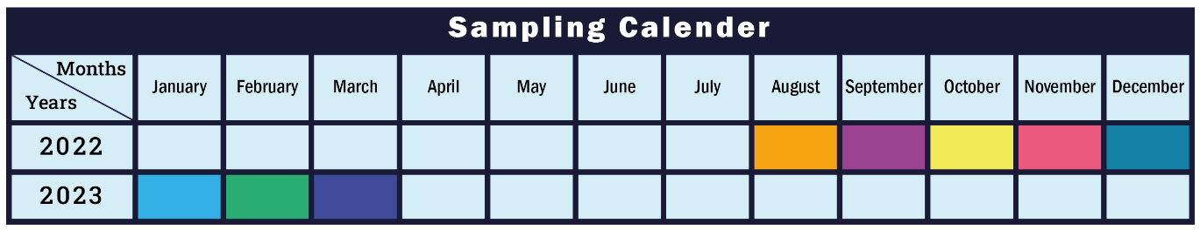
Figure 2: Sampling calendar of the study

Data analysis

Main functions of aLBI package

Table 1. Main Functions of aLBI R package
Functions | Descriptions | Usage | Arguments
FrequencyTable | This function creates a frequency distribution table for fish length data | FrequencyTable(data, method, bin_width, Lmax) | data: A numeric vector of fish lengths.  bin_width: Optional. A numeric value specifying the bin width for class intervals, if left NULL, the bin width is automatically calculated using Wang et al. (2020) optimum bin size (OBS) formula.  Lmax: Optional. The maximum length of fish. If left NULL then automatically calculate the frequency table with the observed maximum length of the provided data.
FishPar | Calculates various length-based indicators for fish stock assessment using length frequency data and bootstrap resampling. | FishPar(data, resample, progress) | data: A data frame containing two columns: Length and Frequency.  resample: An integer indicating the number of bootstraps resamples.  progress: A logical value indicating whether to display progress.
FishSS | Assesses the stock status based on parameters calculated by the FishSS function | FishSS(data, LM_ratio, P_{obj}, P_{mat}, P_{opt}) | data: A data frame containing the necessary columns for stock status calculation. (Cope & Punt, 2009)  LM_ratio: A numeric value representing the ratio of L_{mat} and L_{opt}.  P_{obj}: A numeric value representing the sum of P_{mat}, P_{opt} and P_{mega}.  P_{mat}: A numeric value representing the percentage of mature fish.  P_{opt}: A numeric value representing the percentage of optimally sized fish.
The FrequencyTable function generates the frequency table as well as provide a data frame containing the upper length class and their corresponding frequencies. With this frequency table the FishPar function facilitates the analysis by estimating key biological parameters, such as the maximum length (L_{max}), asymptotic length (L∞), and length at maturity (L_{mat}), using bootstrap resampling techniques (Table 1). It ensures data integrity by validating input data and generating robust confidence intervals for parameter estimates. Additionally, it provides insightful visualizations to help interpret the results, making it a valuable tool for researchers and fishery managers. In addition, the FishPar function also calculate particular indicators such as L_{mat}/L_{opt} ratio (LM_ratio) and sum of P_{mat} P_{opt} P_{mega} (P_{obj}) to ascertain the stock situation. Analyzing these indications helps one to choose suitable columns from the input data to create important stock metrics such Limit Spawning Biomass (LSB25) and Target Spawning Biomass (TSB40) (Table 1). This dual-function strategy improves our knowledge of fish population dynamics, therefore helping to guide the development of sensible management plans and fisheries policies.

Calculating frequency table
Frequency distribution table was constructed using the following formula of optimum bin size (OBS) recommended by Wang et al. (2020), facilitate by the FrequencyTable function of aLBI package.
Optimum Bin Size (OBS) =(0.23*(Lmax0.6)............... (1)
L_{max} = Maximum length

Estimating growth parameters by FishPar function

L_{max} will be estimated from the length frequency data by FishPar function as followed:
Lmax=max⁡(data[1]) ……………. (3)

Lmax=max⁡(data[1])
Here, data[1] = first column of the length frequency data where length of the sampled data was recorded and pick up the largest length by max formula.
Then an initial value for asymptotic length (L∞) was calculated using the following formula proposed by Pauly (1984):
$L_{∞}=\frac{L_{max}}{0.95}$……………. (4)

To estimate the length at sexual maturity (L_{m}), an empirical equation proposed by Froese & Binohlan (2000) was used as followed:
$\log\left(L_{m}\right)=0.8979\left(\log\left(L_{∞}\right)\right)-0.0782$……………. (5)

Estimating Length-Based Indicators (LBIs) by FishPar function
In order to evaluate the stock status in relation to exploitation and prevent excessive fishing that could harm development and recruitment, Froese (2004) suggested three straightforward length-based indicators (LBIs) known as P_{mat}, P_{opt}, and P_{mega}.
- The first indicator P_{mat}, can be defined as the proportion of mature fish in the catch, and it represents the concept of “let them spawn!” The objective is to ensure that every single fish (100%) is able to reproduce at least once before being caught, in order to restore and sustain a robust spawning biomass of fisheries. The percentage of fish in the capture that have a length larger than the length at sexual maturity (L_{m}) was determined using the following formula proposed by Froese (2004):
$P_{mat}=\sum_{L_{mat}}^{L_{max}}{P_{L}}$………………... (6)
Where, P_{L} is the percentage of fish in the catch composition with a length interval of L.

- Indicator two P_{opt}, defined as the percentage of fish caught at their optimal length, which is the length that maximizes the yield and revenue. The optimum length is generally somewhat bigger than the length at initial maturity and can be readily determined using growth and mortality parameters or empirical equations (Froese & Binohlan, 2000). The objective is to capture every fish (100%) within a range of around ±10% (between 0.9L_{opt} and 1.1L_{opt}) of the optimal length. L_{opt} and P_{opt} were calculated by following formula:
logLopt=1.053logLmat-0.0565……………. (7)
$P_{opt}=\sum_{{0.9L}_{opt}}^{{1.1L}_{opt}}{P_{L}}$…………… (8)
- The P_{mega}, defined as the percentage of old and larger fish (mega = mega spawner) in the catch composition. The metric is calculated as the proportion of mature fish in the catch that exceed the optimal length by 10%. The purpose of the management regime is to execute a fishing technique that ensures no mega-spawners are caught, with a goal of 0% catch rate. In the absence of such strategy, a range of 30-40% mega-spawners is indicative of a robust structure and is considered favorable (Froese, 2004). However, if the proportion falls below 20%, it is a cause for concern. The following equation was used to estimate P_{mega} proposed by Froese (2004):
$P_{mega}=\sum_{{1.1L}_{opt}}^{L_{max}}{P_{L}}$…………… (8)

Stock spawning biomass (SB) evaluation
FishSS function evaluate the stock status (limit spawning biomass and target spawning biomass) from a decision table (CPdata) (Figure 3) demonstrated by Cope and Pund (2009) which is readily available with the aLBI package based on the input parameters (LM_ratio, Pmat, Popt, Pmega) estimated by FishPar function. For detail understanding about the following flowchart see the CPdata provided by the aLBI package.
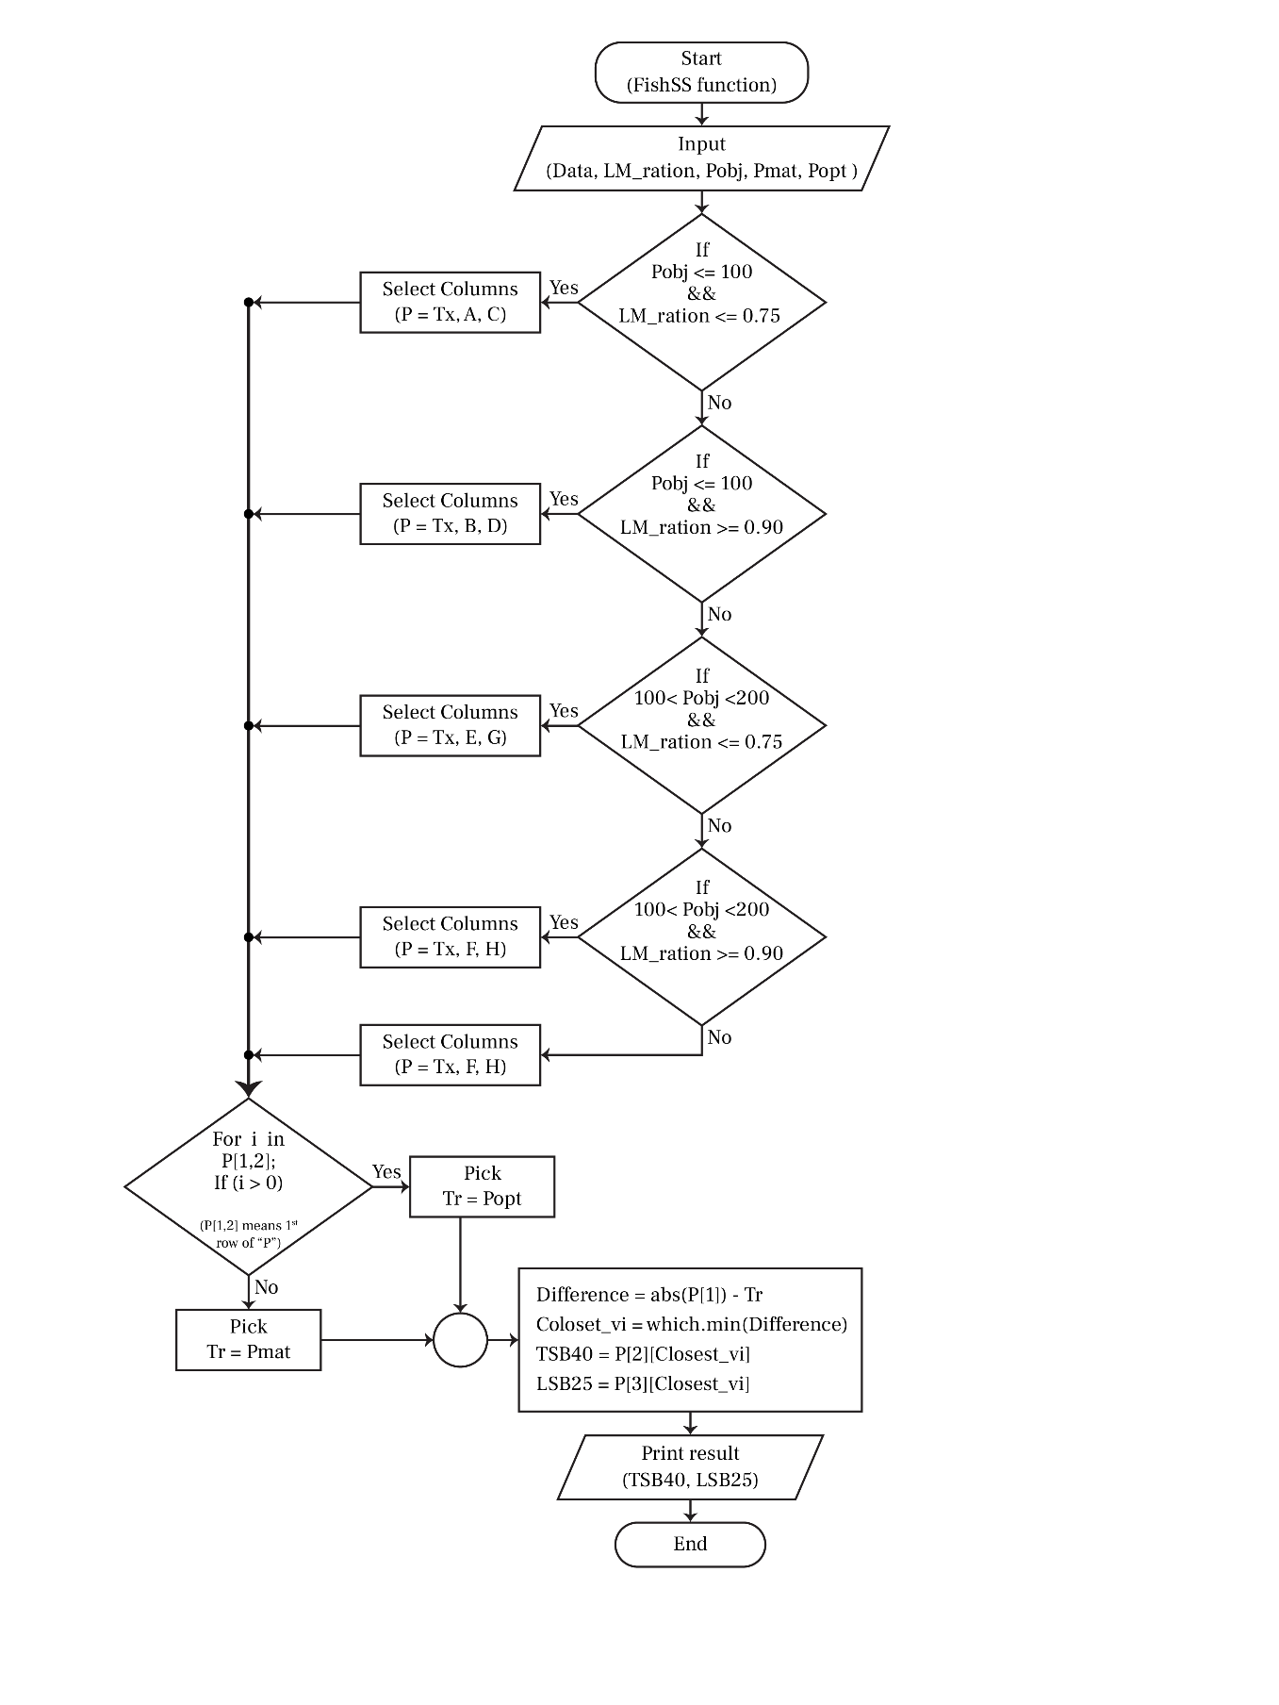
Figure 3: Flow chart of the decision tree adopted from Cope and Punt (2009)

Evaluating the robustness of the aLBI package
To evaluate the robustness of the aLBI package under varying bin sizes, the length frequency data were rearranged using the FrequencyTable function of the aLBI package with bin sizes of 1, 2, 4, and 5, in addition to the base model with a bin size of 3. The uncertainty in length-based indicators (LBIs) (P_{mat}, P_{opt}, and P_{mega}) was propagated from the uncertainty in key length parameters such as length at maturity (L_{mat}), optimal length (L_{opt}), and maximum length (L_{max}). The uncertainty in these length parameters was estimated through a bootstrapping approach, which resampled the length data 1,000 times to generate confidence intervals for each parameter. The bootstrapped estimates were then used to calculate the LBIs for each bin size. This approach ensured that the variability inherent in the length data was accounted for in the robustness evaluation. Statistical analyses, including one-way ANOVA and Tukey's HSD test, were performed to test for significant difference in length parameters as well as LBI estimates across the different bin sizes.

Bootstrap resampling procedure
This study applied a bootstrap resampling technique to assess the uncertainty in length matrices and to propagate this uncertainty through the estimation process. For each bootstrap iteration, FishPar function randomly resampled the length-frequency data with replacement (Efron, 1992), generating resampled datasets of the same size as the original. Key length parameters, such as L_{max}, L∞, L_{mat}, and L_{opt}, were estimated from these resampled datasets. Firstly, L_{max} was determined as the maximum observed length in the resampled data, and then L∞ was derived by assuming it is 95% of L_{max}. L_{mat}, L_{opt}, L_{opt_p10}, and L_{opt_m10} were estimated using mentioned formulas. Additionally, we calculated Froese (2004) length-based indicators (P_{mat}. P_{opt}, P_{mega}) by aggregating the length-frequency data into bins and computing the proportion of the total catch in the respective length ranges. The uncertainty in the estimates of L_{max}, L_{opt}, and other indicators was propagated by calculating 95% confidence intervals (CIs) from the 2.5th and 97.5th percentiles of the bootstrap distribution for each indicator.

RESUTS

Installation of the package
The package (aLBI) is accessible on GitHub repository (for latest update) and also available on CRAN (https://cran.r-project.org/web/packages/aLBI/index.html). For detailed installation instructions, troubleshooting tips, and additional information, users can refer to the vignettes (https://cran.r-project.org/web/packages/aLBI/vignettes/Introduction.html).

Observed output of FishPar function
Length frequency data of S. aor was given input to the aLBI package for estimating the parameters and visualization of the plots for understanding the stock status.

Frequency distribution plot
The total lengths (TL) of 1177 S. aor individuals, ranging from 9.5 to 75 cm were measured. A frequency table with an optimum class intervals of 3 cm and a unimodal length frequency distribution plot (Figure 4) was produced by aLBI package. The observed frequencies represented by bars, revels the highest abundance of individuals within the length class of 27 cm (156 individuals) and followed by 30 cm (143 individuals), 21 cm (137 individuals), 24 cm, 18cm both with the same count (135 individuals), indicating these lengths are common among the sampled fish population.
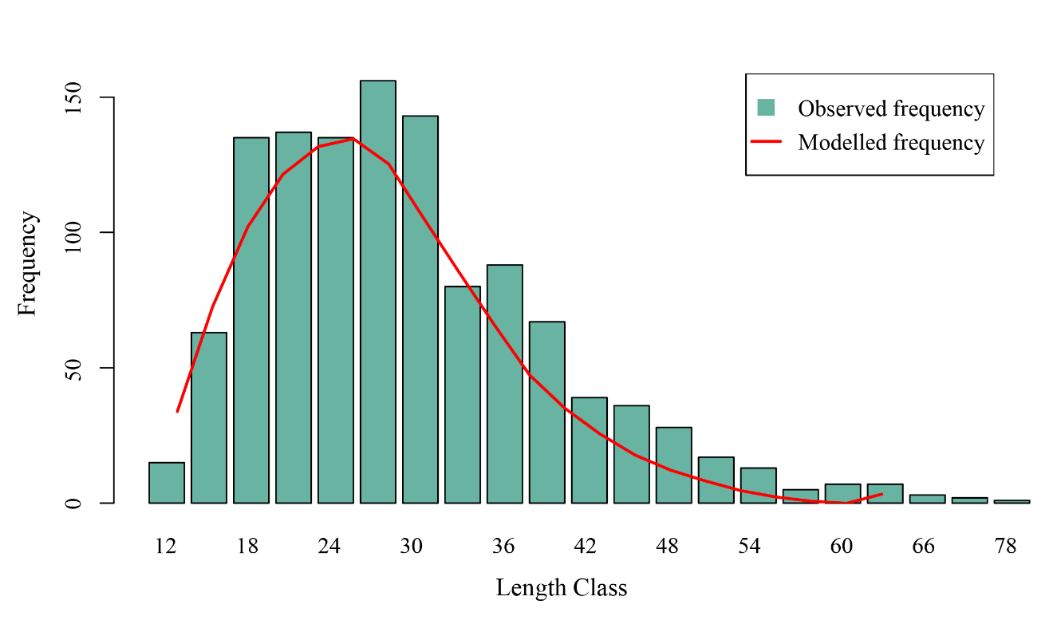
Figure 4: Plot showing the length frequency distribution of S. aor.

The red curve, representing the model frequency, aligns closely with the observed data and highlighting the accuracy of the applied model. The plot was found to be heavily skewed towards left side, indicating good recruitment but also potential growth overfishing.

Estimating different length groups
The aLBI package produced a plot (Figure 5) for different length groups of S. aor. The length-based metrics provided a comprehensive understanding of the fish stock status. The plot depicts the mean maximum length (L_{max}) of 74.27 cm with a confidence interval (CI) 63.00 to 78 cm and asymptotic length (L∞) of 78.17 cm with a CI of 66.32 to 82.11 cm, indicating that the species has the potential to attain considerable sizes under optimal conditions and minimal fishing pressure. The mean length at sexual maturity (L_{mat}) of 41.83 cm with a CI 36.09 to 43.72 cm. The mean optimum length (L_{opt}) is 44.77 cm. On the contrary, the estimated range for L_{mat}±10% of L_{opt} is 40.29 ( with a CI 34.49 to 42.21) to 49.24 cm (with a CI 42.16 to 51.59) (Table 2), represents the ideal range which produces maximum biological yield.
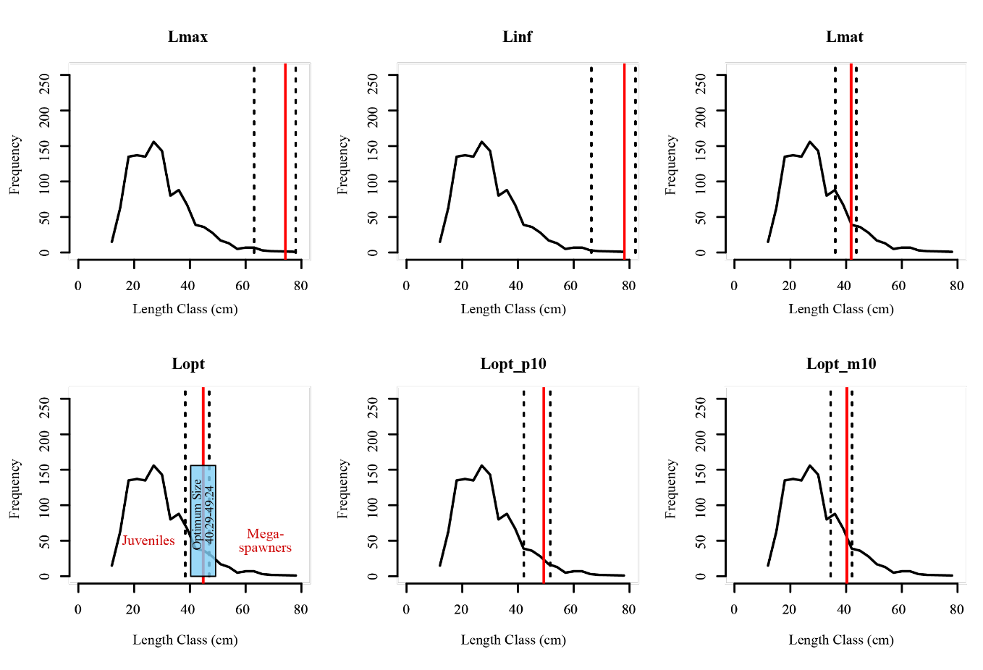
Figure 5: Plot showing the frequency line with different length parameters of Seperata aur. Solid red lines depict the mean estimates and dotted lines depicts the lower (LCI) and upper confidence intervals (UCI).
Estimated length based parameters of S. aor and their respective confidence intervals are showing in the Table 2.
Table 2: Different length parameters of S. aor
Parameters | Mean (cm) | LCI | UCI
L∞ | 78.17 | 66.32 | 82.11
L_{max} | 74.27 | 63.00 | 78.00
L_{mat} | 41.83 | 36.09 | 43.72
L_{opt} | 44.77 | 38.32 | 46.90
L_{opt_p10} | 49.24 | 42.16 | 51.59
L_{opt_m10} | 40.29 | 34.49 | 42.21

Scenario produced with different bin size for length parameters
The boxplot (Figure 6) illustrates the consistency of the estimated length parameters (L∞, L_{mat}, L_{max}, L_{opt}, L_{opt_m10}, and L_{opt_p10}) across different biz sizes (1 to 5, with the base model bin size of 3). The estimated values of L∞ and L_{max} exhibited minimal deviations from the base model, ranging from +1.74% to -0.8%, while L_{mat} and L_{opt} showed deviations of +1.57% to -0.71% and +1.65% to -0.75%, respectively. Statistical analysis using One-Way ANOVA and Tukey's post-hoc test confirmed that the differences in estimated length parameters across different bin sizes were not significant (p > 0.05).
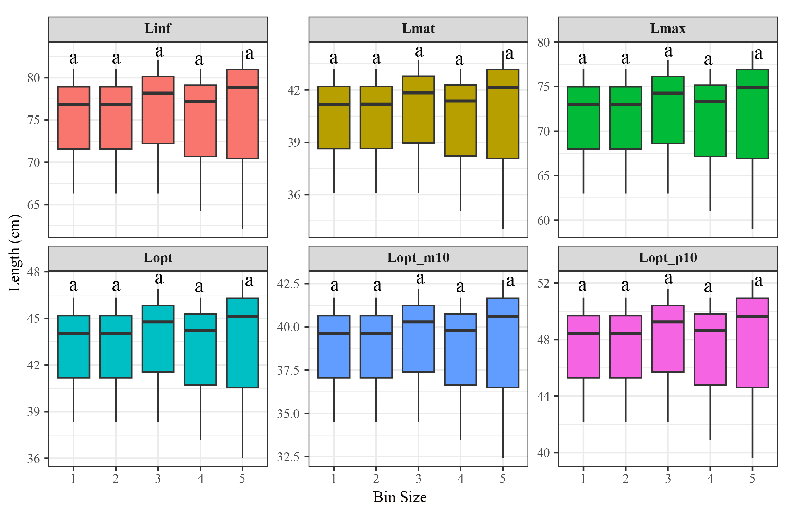
Figure 6: Distribution of length parameters with different bin size (base model bin size = 3), represented with the mean, lower and upper confidence intervals. Shared letter (a) indicating no significant differences (p > 0.05) in the estimation of length parameters with different bin size based on one-way ANOVA and Tukey’s HSD.

Length-Based Indicators (LBIs)
The simple set of indicators (P_{mat}. P_{opt}, P_{mega}) proposed by Froese (2004), were estimated for the stock of Sperate aor (Table 3) reveal significant deviations from the target reference values. The percentage of sexually mature fish (P_{mat}) was 12.48% (7.55–22.69%), far below the target of 100%, indicating heavy exploitation of immature fish and reduced reproductive potential. Similarly, the percentage of optimally sized fish (P_{opt}) was 9.03% (5.14–17.24%), substantially below the 100% target, reflecting insufficient numbers of fish reaching their full growth potential. The proportion of mega-spawners (P_{mega}), crucial for genetic diversity and population resilience, was only 5.09% (2.41–11.79%), compared to the target of 20%, highlighting that this fishery has already removed major portion of its larger individuals. The combined indicator (P_{obj}) was 26.61% (15.09–51.71%), further underscoring the stock's unsustainable status.
Table 3: Estimated length-based indicators (LBIs)
Parameters | Mean (%) | LCI | UCI
P_{mat} | 12.48 | 7.55 | 22.69
P_{opt} | 9.03 | 5.14 | 17.24
P_{mega} | 5.09 | 2.41 | 11.79
P_{obj} | 26.61 | 15.09 | 51.71

Scenario produced with different biz size for the aLBI indicators
The boxplot (Figure 8) illustrates the robustness of the method by producing identical results for (P_{mat}, P_{opt}, P_{mega}) across different biz sizes (1 to 5, with a base model bin size of 3) using aLBI package. The propagated uncertainty from the length parameters (L_{mat,} L_{opt} and L_{max}) resulted in minor deviations from the base model. Specifically, the deviation for P_{mat} ranges from +0.13% to -2.60%, for P_{opt} -0.4% to -3.25% and for P_{mega} -1.07% to 1.53%. Statistical analysis using One-Way ANOVA and Tukey's post-hoc test confirmed that the differences in estimated length parameters across different bin sizes were not significant (p > 0.05).

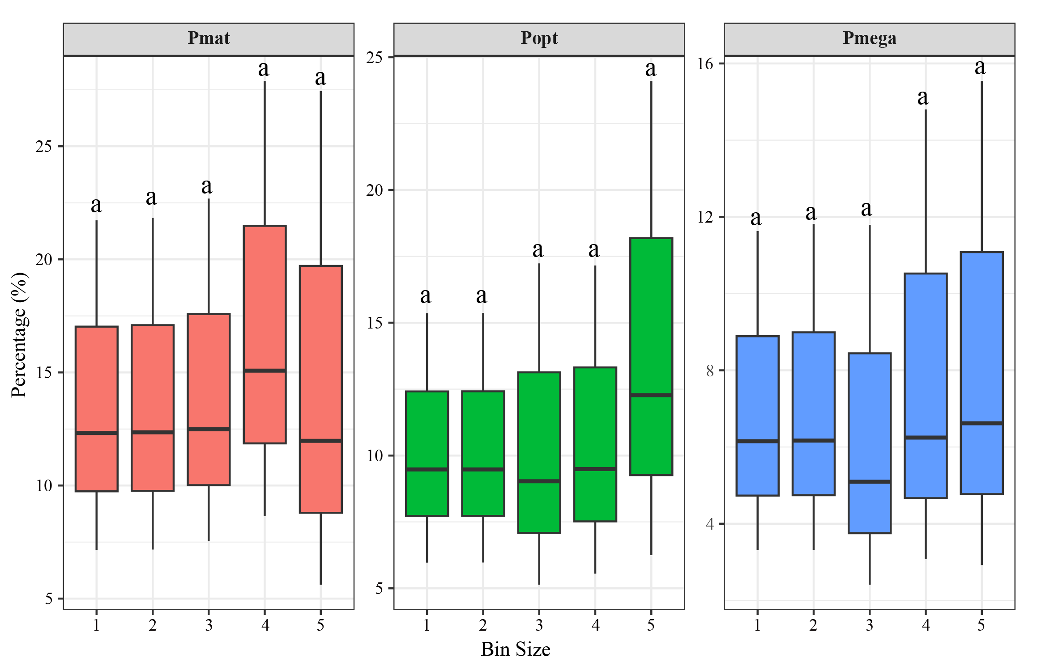
Figure 8: Distribution of LBIs with different bin size, represented with the mean, lower and upper confidence intervals. Shared letter (a) indicating no significant differences (p > 0.05) in the estimation of length parameters with different bin size based on one-way ANOVA and Tukey’s HSD.

Observed stock status of FishSS function
FishSS function facilitate the evaluation of stock status by quantifying the decision tree process. The sum of the all the three proportions (P_{mat}, P_{opt}, P_{mega}), termed as P_{obj}, provides comprehensive information to distinguish the selectivity patterns. However, the findings (Table 4) suggest that there is a probability that the stock biomass below the target reference points or exceed both the target biomass level (TSB40) and the limit biomass level (LSB25). These reference points were also found below the target reference points with different bin size.
Table 4. Estimated stock status of the S. aor by aLBI package
Bin size | Probability (%) of TSB40 | Probability (%) of LSB25
1 | 67 | 67
2 | 67 | 67
3 | 67 | 67
4 | 52 | 44
5 | 67 | 67

DISCUSSION

Development and application of the aLBI package
Especially in data-limited conditions, the development of the aLBI package was motivated by the need of robust tools to evaluate fish stock situation using length-based indicators. Applying methods proposed by Froese (2004) and Cope & Punt (2009), the package generates a whole framework for computing significant parameters like L_{max}, L∞, L_{mat}, and L_{opt} as well as percentage indicators including P_{mat}, P_{opt}, and P_{mega}. These tools enable data-driven insights capable of guiding sustainable fisheries management. The ability of the program to visualize length frequency distributions and calculate confidence intervals helps managers and fisheries researchers to evaluate the health of any fish stock along with the uncertainties associate with the estimated parameters. By allowing managers to use effective conservation measures and reach sustainable exploitation rates, the package helps decision-making by means of clear, pragmatic indicators.

Performance evaluation of aLBI package

Frequency table and distribution curve
In addition to calculating the default optimum bin size using the formula proposed by Wang et al. (2020), the FrequencyTable function in the aLBI package allows users to specify a custom bin size. This feature significantly enhances the package's flexibility, enabling users to tailor the frequency table construction to their specific dataset or analytical needs. In this study, the optimum bin size was calculated to be 3.07, which was rounded to 3 for practical purposes and used as the base model bin size. Using this bin size, the FishPar function constructed the frequency distribution curve for S. aor. The curve demonstrates a gradual decline in frequency beyond the 30 cm length class, indicating a reduced number of individuals in larger size categories. The dominance with smaller-length individuals (Juveniles) indicates this fishery mainly targeting the juveniles (Thorson et al., 2014). Mia et al. (2024) and Bashar et al. (2021) reported a similar selectivity pattern for Ailia coila and Eutropiichthys vacha in this Kaptai Lake. According to the “The Protection and Conservation of Fish Act, 1950”, catching fish with a length smaller than 23 cm is prohibited in this Lake (Rayhan et al., 2021). However, present and previous findings (Mia et al., 2024; Bashar et al., 2021) revealed the violation of this rules because of the absence of proper monitoring settings.

Different length parameters and their uncertainty
The length parameters such as L_{max}, L∞, L_{mat}, and L_{opt} are important matrices for fisheries management. L_{max} serves as an indicator of the population structure and is closely associate with the fishing activities. The mean length at maturity (L_{mat}) underscores the critical threshold for reproductive capacity, while catching fish at the optimum length (L_{opt}) maximizes biological yield. These metrics emphasize the necessity of implementing size limits to protect both juveniles and mature fish. no prior studies have investigated these parameters for S. aor in Kaptai Lake.
Table 5: Estimated length parameters from different region of South Asia.
Regions | L∞ | L_{max} | L_{opt} | L_{mat} | Reference
Bangladesh | 98.95* | 94.00 | 56.65* | 52.66* | Rahman, 2005
India | 125.26* | 119 | 70.80* | 65.08* | Khan et al., 2019
India | 192.42* | 182.8 | 106.24* | 95.68* | Day, 1878; Misra, 1959
India | 128.42* | 122.00 | 72.49* | 66.55* | Job et al., 1955
India | 166.44* | 158.12* | 92.63* | 84.00 | Saigal, 1964
India | 108.72* | 103.28* | 61.92* | 57.30 | Ramakrishniah, 1992
Narora–Kanpur, India | 96.50 | 90.10 | 54.43* | 50.69* | Nazir & Khan, 2020
Varanasi, India | 92.30 | 89.10 | 53.85* | 50.19* | Nazir & Khan, 2020
Bhagalpur, India | 89.10 | 85.40 | 51.74* | 48.31* | Nazir & Khan, 2020
India | 85.68* | 81.40 | 49.44* | 46.27* | Nazir & Khan, 2019
Pakistan | 189.47* | 180.00 | 104.70* | 94.36* | Talwar & Jhingran, 1991; Tripathi, 1996
Bangladesh | 78.17 | 74.27 | 44.77 | 41.83 | Present study
* Calculated by using motioned formula in the methodology from L_{max} or L_{mat}
Previous studies conducted in various South Asian regions (e.g., Day, 1878; Misra, 1959; Talwar and Jhingran, 1991; Tripathi, 1955; Rahman, 2005; Sigal, 1964; Ramakrishniah, 1992; Khan et al., 2019; Job et al., 1955) have reported estimates for L_{max}, L∞, L_{opt,} and L_{mat} that are significantly higher than the present study’s findings (Table 4). While habitat quality and environmental conditions are critical factors influencing fish growth (Garcia et al., 2003; Alam et al., 2013), intense fishing pressure (especially high removal of juveniles) plays a major role in reducing the mean length of fish populations (Alam et al., 2021). This reduction in mean length contributes to declines in key length-based parameters and drives earlier maturation, as fish are increasingly exploited before they reach their full growth potential (Alam et al., 2021).
Different bin size analysis demonstrated a clear distribution of length parameters, showcasing central tendencies, interquartile ranges, and variability. The robustness of the modeling approach was validated through the consistent estimates of L∞, L_{mat}, L_{max}, L_{opt}, L_{opt_p10}, and L_{opt_m10} across various bin sizes. Deviations in these estimates remained within ±2%, and statistical analysis confirmed no significant differences (p > 0.05) in parameter values across bin sizes. This robustness is critical for ensuring reliability in length-based stock assessments, as it indicates that the model's performance is unaffected by the choice of bin size. This finding corroborates the work of Hordyk et al. (2015), who demonstrated that length-based methods are robust tools for evaluating fish stock status, even under data-limited scenarios. These findings further support the utility of the aLBI package for fisheries resource management, offering a flexible and reliable tool for estimating key length-based parameters essential for sustainable exploitation and conservation of fish stocks.

Length-based indicators (LBIs)
The findings from length-based indicators (LBIs) estimated using the aLBI package, with bootstrapped confidence intervals, provide critical insights into the fish stock's health. The low percentage of sexually mature fish (12.48%) indicates that approximately 87% of individuals are excluded from the population before reaching maturity, a critical sign of growth overfishing which significantly reduces reproductive capacity and long-term sustainability of the stock. On the hand, the low proportions of optimally sized (9.03%) and mega spawner (5.09%) reflecting the recruitment over-fishing of the fishery. The significant depletion of mega-spawners (P_{mega} < 20%) suggests heavy fishing pressure on larger, older individuals, threatening genetic diversity and resilience (Mace & Sissenwine, 1993; Mora et al., 2009; Barneche et al., 2018; Rudd & Thorson, 2018). Thus, management strategies should be developed for ensuring the immature individuals can grow and spawn at least once before they are caught and the mega spawners remain intake (Barrowman & Myers, 1996; Hilborn, 2007; Alam at el., 2022). These strategy will maintain the reproductive success of the population (Froese, 2004; Hilborn et al., 2020). These results align with earlier research showing that overfishing usually results in an overpopulation of young fish, which, under poor management, could cause recruitment overfishing (Beverton & Holt, 1957; Cushing, 1988). Furthermore, ensuring the genetic variety and long-term population health depends on keeping a balanced size distribution (Hixon et al., 2014).

Evaluation of stock status
The stock status probabilities for target spawning biomass (TSB40) and limit spawning biomass (LSB25) across various bin sizes are below their respective target reference points. Moreover, the ratio of length for sexually mature fish to the optimally-sized fish (L_{mat}/L_{opt} > 0.9) and the combined percentage of optimally-sized and the mega spawners (P_{opt} + P_{mega} > 0) indicate selectivity patterns favoring the capture of smaller and optimally-sized fish while avoiding the larger individuals. Since, there is no strategy for releasing the mega spawners from the catch, this finding also indicates the absence of larger S. aor individuals in this Lake. Previous studies (Mia et al., 2024; Bashar et al., 2021) also reported low percentage of mega spawners for A. coila and E. vacha in this Lake. Given the multi-gear and multi-species nature of Kaptai lake fisheries it can be concluded that major portion of mega spawners of different species have already been removed from this Lake by the existing selectivity pattern of the fisheries.

Recommendations for Management
The findings from the aLBI package emphasize the urgent need for policy interventions to safeguard the reproductive biomass of the fishery. With a high proportion of juveniles in the catch, the optimal target length class (P_{opt}) accounts for only about 10% or less of the total catch composition. Thus, Immediate gear modifications are essential to prevent further stock depletion. Although existing regulations prohibit the capture of fish ≤23 cm in length, this study highlights the inadequacy of such measures in protecting the S. aor stock. The analysis suggests that the minimum length limit for this species should be at least 40 cm. Additionally; to conserve older, larger individuals crucial for the reproductive success of the stock, an upper length limit of 49 cm is recommended. However, implementing different size limits for the same gear may not be feasible in resource-limited contexts. Therefore, the study proposes a single lower length limit of 40 cm, ensuring that all fish have the opportunity to mature and spawn at least once in their lifetime. If this regulation is enforced effectively, the fishery can remain sustainable, even with the removal of mega-spawners.

Conclusion
The length-based indicators (LBIs) for fisheries sustainability proposed by Froese (2004), have been widely validated and recognized in international literature. Leveraging their proven effectiveness, this study evaluates the stock status of S. aor from Kaptai Lake, Chittagong, Bangladesh. To provide robust and reliable estimates of these indicators, the study also introduces an R package "aLBI." In addition to estimating LBIs, the package incorporates procedures to address the uncertainties associated with these estimates. It also examines the impact of varying bin sizes on the calculation of indicator values. For the S. aor stock, no significant differences were observed across different bin sizes, demonstrating the package's reliability compared to traditional LBI estimation methods. The outputs estimated by the aLBI package reveal that the fishery predominantly targets immature individuals of the species. To safeguard the stock and promote sustainability, this study recommended a lower length limit 40 cm. Enforcing this measure will ensure the sustainability of the fishery in Kaptai Lake.

Author Contributions

A.A.: conceptualization, developing, methodology, data collection, data analysis, visualization, and writing, M.R.S.: writing, reviewing and editing, M.S.A.: conceptualization, methodology, data analysis, writing, reviewing, editing, and supervision. All authors have read and agreed to the published version of the manuscript.

Ethics Statement

The authors have nothing to report.

Conflicts of Interest

The authors declare no conflicts of interest.

Data Availability Statement

Data will be available on request to corresponding author.
Funding
The authors received no specific funding for this research.

REFERENCES

Alam, M. S., Hossain, M. S., & Monwar, M. (2013). Assessment of fish distribution and biodiversity status in Upper Halda River, Chittagong, Bangladesh. International Journal of Biodiversity and Conservation, 5(6), 349–357.
Alam, M. S., Liu, Q., Nabi, M. R.-U.-, & Al-Mamun, M. A. (2021). Fish stock assessment for data-poor fisheries, with a case study of tropical Hilsa Shad (Tenualosa ilisha) in the water of Bangladesh. Sustainability, 13(7), 3604.
Ault, J. S., Smith, S. G., Bohnsack, J. A., Luo, J., Stevens, M. H., DiNardo, G. T., Johnson, M. W., & Bryan, D. R. (2019). Length-based risk analysis for assessing sustainability of data-limited tropical reef fisheries. ICES Journal of Marine Science, 76(1), 165–180. https://doi.org/10.1093/icesjms/fsy123
Barneche, D. R., Robertson, D. R., White, C. R., & Marshall, D. J. (2018). Fish reproductive-energy output increases disproportionately with body size. Science, 360(6389), 642–645. https://doi.org/10.1126/science.aao6868
Barrowman, N. J., & Myers, R. A. (1996). Is fish recruitment related to spawner abundance. Fishery Bulletin, 94, 707-724.
Bashar, M. A., Rahman, M. A., Uddin, K. B., Ahmed, F. F., Mahmud, Y., & Hossain, M. Y. (2021). Assessing the exploitation status of main catfish Eutropiichthys vacha based on length-based stock assessment models in the Kaptai Lake from Bangladesh. Heliyon, 7(9). https://doi.org/10.1016/j.heliyon.2021.e08046
Beverton, R. J. H., & Holt, S. J. (1957). On the dynamics of exploited fish populations. Fisheries Investigations Series II, Volume 19, 533 pages. HMSO, London.
Canales, C. M., Hurtado, C., & Techeira, C. (2018). Implementing a model for data-poor fisheries based on steepness of the stock-recruitment relationship, natural mortality and local perception of population depletion. The case of the kelp Lessonia berteroana on coasts of north-central Chile. Fisheries Research, 198, 31–42. https://doi.org/10.1016/j.fishres.2017.10.017
Chong, L., Mildenberger, T. K., Rudd, M. B., Taylor, M. H., Cope, J. M., Branch, T. A., Wolff, M., & Stäbler, M. (2020). Performance evaluation of data-limited, length-based stock assessment methods. ICES Journal of Marine Science, 77(1), 97–108. https://doi.org/10.1093/icesjms/fsz212
Cope, J. M., & Punt, A. E. (2009). Length‐Based Reference Points for Data‐Limited Situations: Applications and Restrictions. Marine and Coastal Fisheries, 1(1), 169–186. https://doi.org/10.1577/C08-025.1
Cushing, J. m. (1988). Nonlinear Matrix Models and Population Dynamics. Natural Resource Modeling, 2(4), 539–580. https://doi.org/10.1111/j.1939-7445.1988.tb00046.x
Day, F. (1878). The Fishes of India Being a Natural History of the Fishes Known to Inhabit the Seas and Fresh Waters of India, Burma and Ceylon. London: William Dowson and Sons. p. 778.
DoF. (2023). Yearbook of fisheries statistics of Bangladesh, 2022-23. Fisheries Resources Survey System (FRSS), Ministry of Fisheries and Livestock, Volume 40, 138p.
Efron, B. (1992). Bootstrap Methods: Another Look at the Jackknife. In S. Kotz & N. L. Johnson (Eds.), Breakthroughs in Statistics: Methodology and Distribution (pp. 569–593). Springer. https://doi.org/10.1007/978-1-4612-4380-9_41
FAO. (2020). The state of world fisheries and aquaculture 2020. Food and Agriculture Organization of the United Nations.
Free, C. M., Jensen, O. P., Wiedenmann, J., & Deroba, J. J. (2017). The refined ORCS approach: A catch-based method for estimating stock status and catch limits for data-poor fish stocks. Fisheries Research, 193, 60–70. https://doi.org/10.1016/j.fishres.2017.03.017
Froese, R. (2004). Keep it simple: Three indicators to deal with overfishing. Fish and Fisheries, 5(1), 86–91. https://doi.org/10.1111/j.1467-2979.2004.00144.x
Froese, R., & Binohlan, C. (2000). Empirical relationships to estimate asymptotic length, length at first maturity and length at maximum yield per recruit in fishes, with a simple method to evaluate length frequency data. Journal of Fish Biology, 56(4), 758–773. https://doi.org/10.1111/j.1095-8649.2000.tb00870.x
Froese, R., Winker, H., Coro, G., Demirel, N., Tsikliras, A. C., Dimarchopoulou, D., Scarcella, G., Probst, W. N., Dureuil, M., & Pauly, D. (2018). A new approach for estimating stock status from length frequency data. ICES Journal of Marine Science, 75(6), 2004–2015. https://doi.org/10.1093/icesjms/fsy078
Galib, S. M., Lucas, M. C., Chaki, N., Fahad, F. H., & Mohsin, A. B. M. (2018). Is current floodplain management a cause for concern for fish and bird conservation in Bangladesh’s largest wetland? Aquatic Conservation: Marine and Freshwater Ecosystems, 28(1), 98–114. https://doi.org/10.1002/aqc.2865
Garcia, S. M., Zerbi, A., Aliaume, C., & Do Chi, T., & Lasserre, G. (2003). The Ecosystem Approach to Fisheries: Issues, Terminology, Principles, Institution Foundations, Implementation and Outlook. In FAO Fisheries Technical Paper, (No. 443).
Gayanilo, F. C., Sparre, P., & Pauly, D. (2005). FAO-ICLARM stock assessment tools II (FiSAT II). Revised version. User's guide. FAO Computerized Information Series (Fisheries), (No. 8).
Gelman, A., & Shalizi, C. R. (2013). Philosophy and the practice of Bayesian statistics. British Journal of Mathematical and Statistical Psychology, 66(1), 8–38. https://doi.org/10.1111/j.2044-8317.2011.02037.x
Hamilton, F. (1822). An Account of the Fishes Found in the River Ganges and Its Branches. Archibald Constable.
Hilborn, R. (2007). Managing fisheries is managing people: What has been learned? Fish and Fisheries, 8(4), 285–296. https://doi.org/10.1111/j.1467-2979.2007.00263_2.x
Hilborn, R., & Walters, C. J. (1992). Role of Stock Assessment in Fisheries Management. In R. Hilborn & C. J. Walters (Eds.), Quantitative Fisheries Stock Assessment: Choice, Dynamics and Uncertainty (pp. 3–21). Springer US. https://doi.org/10.1007/978-1-4615-3598-0_1
Hilborn, R., Amoroso, R. O., Anderson, C. M., Baum, J. K., Branch, T. A., Costello, C., de Moor, C. L., Faraj, A., Hively, D., Jensen, O. P., Kurota, H., Little, L. R., Mace, P., McClanahan, T., Melnychuk, M. C., Minto, C., Osio, G. C., Parma, A. M., Pons, M., Ye, Y. (2020). Effective fisheries management instrumental in improving fish stock status. Proceedings of the National Academy of Sciences, 117(4), 2218–2224. https://doi.org/10.1073/pnas.1909726116
Hixon, M. A., Johnson, D. W., & Sogard, S. M. (2014). BOFFFFs: On the importance of conserving old-growth age structure in fishery populations. ICES Journal of Marine Science, 71(8), 2171–2185. https://doi.org/10.1093/icesjms/fst200
Hoggarth, D. D., Abeyasekera, S., Arthur, R., Beddington, J. R., Burn, R. W., Halls, A. S., & Welcomme, R. L. (2006). Stock assessment for fishery management: A framework guide to the stock assessment tools of the Fisheries Management Science Programme (FMSP). FAO Fisheries Technical Paper, (No. 487).
Hordyk, A. R., Loneragan, N. R., & Prince, J. D. (2015). An evaluation of an iterative harvest strategy for data-poor fisheries using the length-based spawning potential ratio assessment methodology. Fisheries Research, 171, 20–32. https://doi.org/10.1016/j.fishres.2014.12.018
Hossain, M. Y., Rahman, Md. M., Fulanda, B., Jewel, M. a. S., Ahamed, F., & Ohtomi, J. (2012). Length–weight and length–length relationships of five threatened fish species from the Jamuna (Brahmaputra River tributary) River, northern Bangladesh. Journal of Applied Ichthyology, 28(2), 275–277. https://doi.org/10.1111/j.1439-0426.2011.01900.x
Job, T.J., David, A. & Das, K.N. (1955). Fish and fisheries of the Mahanadi in relation to the Hirakund dam. Indian Journal of Fisheries 2(1): 1-40
Khan, S., A. K. Tiwari, Mayank, P., & Tripathi, S. (2019). Size structure of Sperata aor (Gangetic Tengra) from the Ghaghara River at Ayodhya, India. Journal of the Kalash Science, 11(1), 26–30.
Khatun, M. H., Zahangir, M. M., Akhter, B., Parvej, M. R., & Liu, Q. (2023). Clupeids in the kaptai reservoir, a blessing or a curse: Estimation of fisheries reference points. Heliyon, 9(3). https://doi.org/10.1016/j.heliyon.2023.e13818
Lima, R. A., Ali, A., Rahman, M. K., Islam, M. S., Moniruzzaman, M., & Tamanna, T. A. (2023). An overview on hydro-biology and management of Kaptai Lake Fisheries, Bangladesh. International Journal of Aquaculture and Fishery Sciences, 9(3), 029–039.
Mace, P. M., & Sissenwine, M. P. (1993). How much spawning per recruit is enough? Canadian Special Publication of Fisheries and Aquatic Sciences, 120, 101-118.
Martell, S., & Froese, R. (2013). A simple method for estimating MSY from catch and resilience. Fish and Fisheries, 14(4), 504–514. https://doi.org/10.1111/j.1467-2979.2012.00485.x
Mia, A. R., Sarker, M. R., & Alam, M. S. (2024). Quantitative Assessment of Ailia coila (Hamilton, 1822) Fish Population in Kaptai Lake: A Length-Based Approach. Lakes & Reservoirs: Science, Policy and Management for Sustainable Use, 29(1), e12460. https://doi.org/10.1111/lre.12460
Mildenberger, T. K., Taylor, M. H., & Wolff, M. (2017). "TropFishR: An R package for fisheries analysis with length-frequency data." Methods in Ecology and Evolution, 8(11), 1520-1527.
Misra, K.S. (1959). An aid to the identification of the common commercial fishes of India and Pakistan. Records of the Indian Museum, 57: 156-157
Mora, C., Myers, R. A., Coll, M., Libralato, S., Pitcher, T. J., Sumaila, R. U., Zeller, D., Watson, R., Gaston, K. J., & Worm, B. (2009). Management Effectiveness of the World’s Marine Fisheries. PLOS Biology, 7(6), e1000131. https://doi.org/10.1371/journal.pbio.1000131
Nazir, A., & Khan, M. A. (2019). Relationships between fish length, otolith size and otolith weight in Sperata aor (Bagridae) and Labeo bata (Cyprinidae) from the Ganga River, India. Zoology and Ecology, 29(2), 93–98. https://doi.org/10.35513/21658005.2019.2.3
Nazir, A., & Khan, M. A. (2020). Stock-specific assessment of precise age and growth in the long-whiskered catfish Sperata aor from the Ganges River. Marine and Freshwater Research, 71(12), 1693. https://doi.org/10.1071/MF19315
Nelson, G. A. (2017). fishmethods: Fishery Science Methods and Models (1.12-1) [Computer software]. https://cran.r-project.org/web/packages/fishmethods/index.html
Pauly, D. (1984). Fish Population Dynamics in Tropical Waters: A Manual for Use with Programmable Calculators. WorldFish.
Pauly, D., & Morgan, G. R. (Eds.). (1987). Length-based methods in fisheries research (Vol. 13). WorldFish.
Pearce, D., Pearce, C., & Palmer, C. (2002). Valuing the Environment in Developing Countries: Case Studies. Edward Elgar Publishing.
Pilling, G. M., Kell, L. T., Hutton, T., Bromley, P. J., Tidd, A. N., & Bolle, L. J. (2008). Can economic and biological management objectives be achieved by the use of MSY-based reference points? A North Sea plaice (Pleuronectes platessa) and sole (Solea solea) case study. ICES Journal of Marine Science, 65(6), 1069–1080. https://doi.org/10.1093/icesjms/fsn063
Prince, J., Victor, S., Kloulchad, V., & Hordyk, A. (2015). Length based SPR assessment of eleven Indo-Pacific coral reef fish populations in Palau. Fisheries Research, 171, 42–58. https://doi.org/10.1016/j.fishres.2015.06.008
Punt, A. E., Butterworth, D. S., de Moor, C. L., De Oliveira, J. A. A., & Haddon, M. (2016). Management strategy evaluation: Best practices. Fish and Fisheries, 17(2), 303–334. https://doi.org/10.1111/faf.12104
Punt, A. E., Dunn, A., Elvarsson, B. Þ., Hampton, J., Hoyle, S. D., Maunder, M. N., Methot, R. D., & Nielsen, A. (2020). Essential features of the next-generation integrated fisheries stock assessment package: A perspective. Fisheries Research, 229, 105617. https://doi.org/10.1016/j.fishres.2020.105617
Rahman, A.K.A. (2005). Freshwater Fishes of Bangladesh. Zoological Society of Bangladesh, Dhaka, Bangladesh. p. 263.
Rahman, B. M. S., Rahman, M. K., Ali, A., Lima, R. A., Mia, M. L., & Mahmud, Y. (2024). Catch composition, catch per unit effort (CPUE) and species selectivity of fishing gears on multi-species Kaptai Lake in Bangladesh. Heliyon, 10(10). https://doi.org/10.1016/j.heliyon.2024.e31173
Ramakrishniah, M. (1992). Studies on the breeding and feeding biology of Mystus aor (Hamilton) of Nagarjunasagar Reservoir. Proceedings of the National Academy of Sciences, India 62 (B) III: 357-364.
Rana, S., Hasan, Md. N., Bari, A. A., Shimul, S. A., Ahmed, Sk. I., & Nahid, Sk. A. A. (2024). Problems and prospects of fish farming in the Chattogram Hill Tracts of Bangladesh: Community-based aquaculture might be a right choice. Aquaculture and Fisheries, 9(2), 306–313. https://doi.org/10.1016/j.aaf.2022.04.002
Rayhan, N., Schneider, P., Islam, M. S., Rashid, A., Mozumder, M. M. H., Hossain, M. M., Begum, A., & Shamsuzzaman, M. M. (2021). Analyses of Protection and Conservation According to the Fish Act 1950 in Bangladesh’s Kaptai Lake Fisheries Management. Water, 13(20), 2835. https://doi.org/10.3390/w13202835
Rudd, M. B., & Thorson, J. T. (2018). Accounting for variable recruitment and fishing mortality in length-based stock assessments for data-limited fisheries. Canadian Journal of Fisheries and Aquatic Sciences, 75(7), 1019–1035. https://doi.org/10.1139/cjfas-2017-0143
Saigal, B.N. (1964). Studies on the fishery and biology of the commercial catfishes of the Ganga River system. II. Maturity, spawning and food of Mystus (Osteobagrus) aor (Hamilton). Indian Journal of Fisheries 11A (1): 1-44.
Scott, F., Jardim, E., Millar, C. P., & Cerviño, S. (2016). An Applied Framework for Incorporating Multiple Sources of Uncertainty in Fisheries Stock Assessments. PLOS ONE, 11(5), e0154922. https://doi.org/10.1371/journal.pone.0154922
Shalehin, Md. S., Parvez, Md. T., Lucas, M. C., & Galib, S. M. (2022). A case study of illegal fishing causes during seasonal fishery closure in Kaptai Lake, Bangladesh. Fisheries Management and Ecology, 29(5), 542–551. https://doi.org/10.1111/fme.12536
Sparre, P., & Venema, S. C. (1998). Introduction to tropical fish stock assessment. Part 1: Manual. FAO Fisheries Technical Paper, No. 306(1), Rev. 2. FAO.
Suman, K. H., Hossain, M. S., Salam, M. A., Rupok, Q. S. S., & Haque, M. N. (2021). Production Trends, and Challenges for Biodiversity Conservation and Sustainable Fisheries Management of Kaptai Lake, the Largest Reservoir in Bangladesh. Asian Fisheries Science, 34(2). https://doi.org/10.33997/j.afs.2021.34.2.004
Talwar, P.K. & Jhingran, A.G. (1991). Inland Fishes of India and Adjacent Countries. 1st Ed. New Delhi, Bombay and Calcutta: Oxford and IBH Publishing Co. Pvt. Ltd. p. 1063.
Thorson, J. T., & Cope, J. M. (2015). Catch curve stock-reduction analysis: An alternative solution to the catch equations. Fisheries Research, 171, 33–41. https://doi.org/10.1016/j.fishres.2014.03.024
Thorson, J. T., Jensen, O. P., & Zipkin, E. F. (2014). How variable is recruitment for exploited marine fishes? A hierarchical model for testing life history theory. Canadian Journal of Fisheries and Aquatic Sciences, 71(7), 973–983. https://doi.org/10.1139/cjfas-2013-0645
Tripathi, S.D. (1996). Present status of breeding and culture of catfishes in south Asia. In The Biology and Culture of Catfishes, edited by Legendre, M. & Proteau, J.P. Aquatic Living Resources 9(Hors Serie.): 219-228.
Wang, K., Zhang, C., Xu, B., Xue, Y., & Ren, Y. (2020). Selecting optimal bin size to account for growth variability in Electronic LEngth Frequency ANalysis (ELEFAN). Fisheries Research, 225, 105474. https://doi.org/10.1016/j.fishres.2019.105474
Zhou, S., Punt, A. E., Ye, Y., Ellis, N., Dichmont, C. M., Haddon, M., Smith, D. C., & Smith, A. D. (2017). Estimating stock depletion level from patterns of catch history. Fish and Fisheries, 18(4), 742–751. https://doi.org/10.1111/faf.12201

